

**Section A: Student Details**

**Student Numbers:** C1768449, C1837435, C1855365, C1874855, C187632, C1879736

**Section B: Programme AND MODULE DETAILS**

**Degree Programme :** MA International Public Relations and Global Communication Management

**Module Title:** GCM

**Module Code :** MCT-518

**Module Tutor:** Elliot Pill

**SECTION C: ASSIGNMENT DETAILS**

**Assignment Title:** Chinese Smokers (Group Project)

Table of Contents

Chinese Smokers 3

History of Cigarettes 3

Cultural Factors 3

Media Regulation 4

Survey Results 6

Our Campaign 11

Conclusion 14

Bibliography 15

# **Chinese Smokers**

With as many adolescents as there are smoking in China, drastic measures must be taken to raise awareness of the many harms smoking can bring. With factors such as low taxes for cigarettes and the culture surrounding smoking, as well as pre-existing campaigns that focus on the negative health aspects of smoking, creating a campaign that teaches adolescents the effects of smoking will need to be done through something they can relate to and enjoy—sports. However, before we can discuss the campaign in detail, we must first build an understanding of factors will be influencing our campaign, and what might hinder its success.

# **History of Cigarettes**

The first factor that is important to understand is the history behind cigarettes, and why they have become so ingrained in the Chinese culture. Smoking has had a global history of several centuries, which has resulted in China being the world's largest cigarette producer and consumer. Today, the smoking rate of adults over 15 years old in China has reached 316 million smokers—30 percent. China's rapid population growth has boosted human support for the mass sale of cigarettes, making it a significant tobacco polluter in the world.

# **Cultural Factors**

Culturally, smoking is seen as the bond that connects people and is essential function is communication in modern Chinese society. Just as music is a silent language—allowing people who speak different languages to become friends because of music—the same can be said of cigarette. It enables people to "group" and coordinate relationships, go out socially, one can pass a cigarette to the other side to spark a conversation and create new friendships. Kessler as cited by Cheng (1999) suggests that people consider smoking amongst teenagers as a rite of passage. Meanwhile, the need to gain social acceptance from peers exerting tacit pressure and influence also promotes smoking or smoking onset. Furthermore, adolescents are surrounded by smokers their entire lives: parents, relatives, teachers, celebrities. The apparent positive social-cultural disposition to this menace, despite the health implication it poses, creates a problem to any anti-smoking campaign targeting this age group.

Chen et al. has also shown that adolescents who live in economically underdeveloped areas are more likely to smoke. Chen proposes that “that increasing the number and accessibility of public activity spaces and advocating healthy lifestyles can effectively reduce residents’ smoking behavior” (2018). Life satisfaction and social status are key factors for whether an adolescent smokes or not, and as such, are target audience should focus on adolescents between the ages of 12-17, and more specially, those who live in economically underdeveloped areas.

Knowledge of health implications and death is not enough to discourage adolescent from smoking as health is the least of their concerns at this age; it is then important to de-glamorize the idea of smoking in the mind of teenagers.  For instance, most Chinese children between the age of 7 to 17 prioritize video games, sports, movie, fashion, music and the likes, unfortunately, key figures and images associated with promotion of these activities appear to present smoking as ‘cool’. Going forward there is a need to disassociate a delightful representation of smoking from these ideals; the hero/heroin shouldn’t have to smoke in movies. The best characters in video games should be non-smokers whose powers decline with a whiff of cigarette; all in attempts to solicit genuine change in how teenagers see smoking, suffix to say effort need to be implemented through subtle and not so subtle channels.

# **Media Regulation**

With this understanding of our audience in mind, we must also understand the barriers media regulation within China may bring. China is well known as being an authoritarian state that has significant control over its media and press. Xu, B. and Albert, E. (2017) state that ‘Reporters without borders ranked China 176 out of 180 countries 6 worldwide index of press freedom’. Our communication program needs to ensure that we understand the basic media law principles that govern the media industry in China. Because we are working within the lines of the government, we not only have a powerful influence on the content that we are able to make, we still must stick to some platform and multimedia limitations that the government pose against. “To comply with the government each individual site privately employing up to 1000 sensors, additionally approximately 20,000 to 50,000 internet police.” King et al (2013 pg. 1). This strict form of monitoring would ensure that we could disseminate the message of our communications campaigns without critics, especially due to the fact that our campaign deals with an anti-smoking approach within the country so embedded in the practice of smoking.

We must ensure that however much control we have, we are able to use it effectively via beneficial distribution channels. Websites such as Google—that is primarily seen as the search engine of the world has had struggles with China regarding certain websites and features being blocked. However due to research we found out that websites such as Weibo (microblog) are seen as a way towards more liberated options, we could consider presenting our editorial scholarship and experience marketing stream as viral marketing can create a sense of taboo when it comes to communication programs taken under the government. We must however adhere to ‘The great firewall of China’ by the PRC which is a legislative enforce of regulatory measures placed on internet censorship. Therefore, we have noted that we cannot use westernized websites such as Twitter, YouTube for (for our viral campaign) and more, but most specifically websites like Weibo are still governed by these authoritative monitors and as such Weibo is seen as not only a platform for media law in China to be bypassed but in an effect for it to be closely monitor bad behavior too which is often voiced as vague within draft legislation releases of updated media law

Media law is a strict practice in china that if found out as offensive content could contribute to punishments such as jail time, but this is not necessarily the case when it comes to status. The irony being that China still implies that its laws respect the privacy of the people, yet control elements of right to freedom of speech. “Members of Chinas “free-speech elite” are able to express concerns and criticism regarding the government with less fear of punishment than the average Chinese citizen”, and this is “composed of senior government and communist party leaders” as stated within CECC.GOVs *Freedom of expression in China.* It is because of strict media regulations like these, that we not only need to be completely aware and have understanding of; but also need complete support from China’s government for this campaign to be successful.

# **Survey Results**

In order to get a better understanding of what influences adolescents in China to smoke, we created a short survey targeting Chinese students studying at Cardiff University. Although this survey is partially complete, and only has 50 completed questionnaires, the results can still be used as a way to qualify our choices for creating a campaign centered around sports.

When cross-comparing class to whether or not the participant smoked, we discovered that over all, participants of our survey are conscious of the negative effects smoking has. This does not seem to have an immense influence on their choice of smoking or frequency.

**Table 1:** Class x Smoking habits

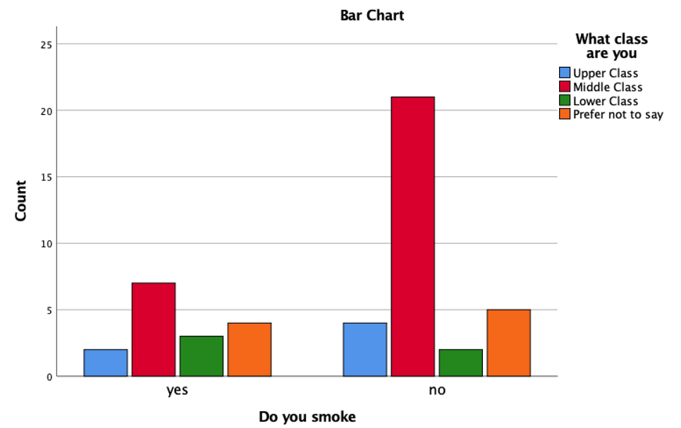

Class does not have an influence on choice of smoking, and according to the study conducted by the Chinese Centre for Disease Control and Prevention and Canadian researchers with the International Tobacco Control project, the majority of smokers are men. According to this survey, 59 percent told the survey they had no plans on quitting.

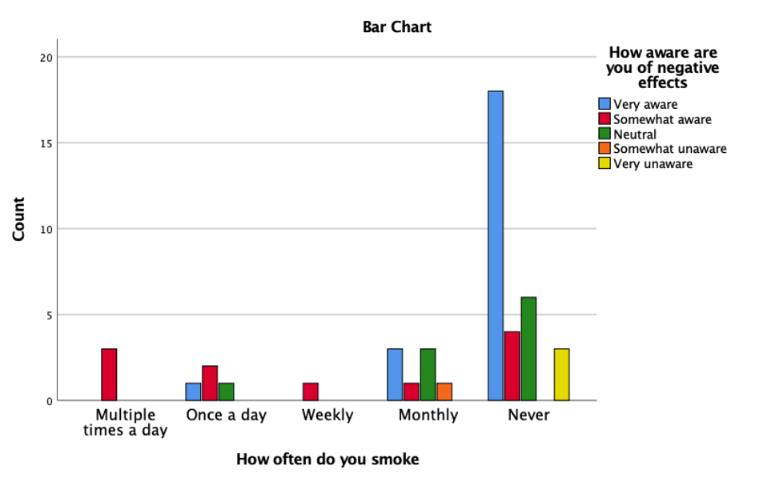

**Table 2:** How aware are you of the negative effects ofsmoking

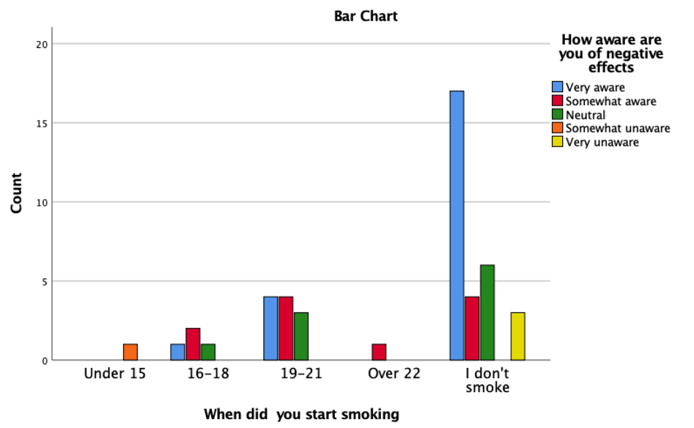Those who started smoking at a younger age were less likely to be conscious of the negative properties smoking has, whereas those who did not most where more likely to know. Speaking directly to the individuals who took this survey, we found that the age one begins to smoke did not have much of an effect one’s understanding of the negative effects smoking has. From the South China Post, 60 percent of Chinese smokers were unaware that cigarettes can lead to stroke, and 40 percent were not aware that smoking can cause heart disease. While this study contradicts our findings, it can

be explained by Chen et al’s findings of economically under-developed cities having higher rates of smokers.

**Table 3:** Smoking Habits x Influences

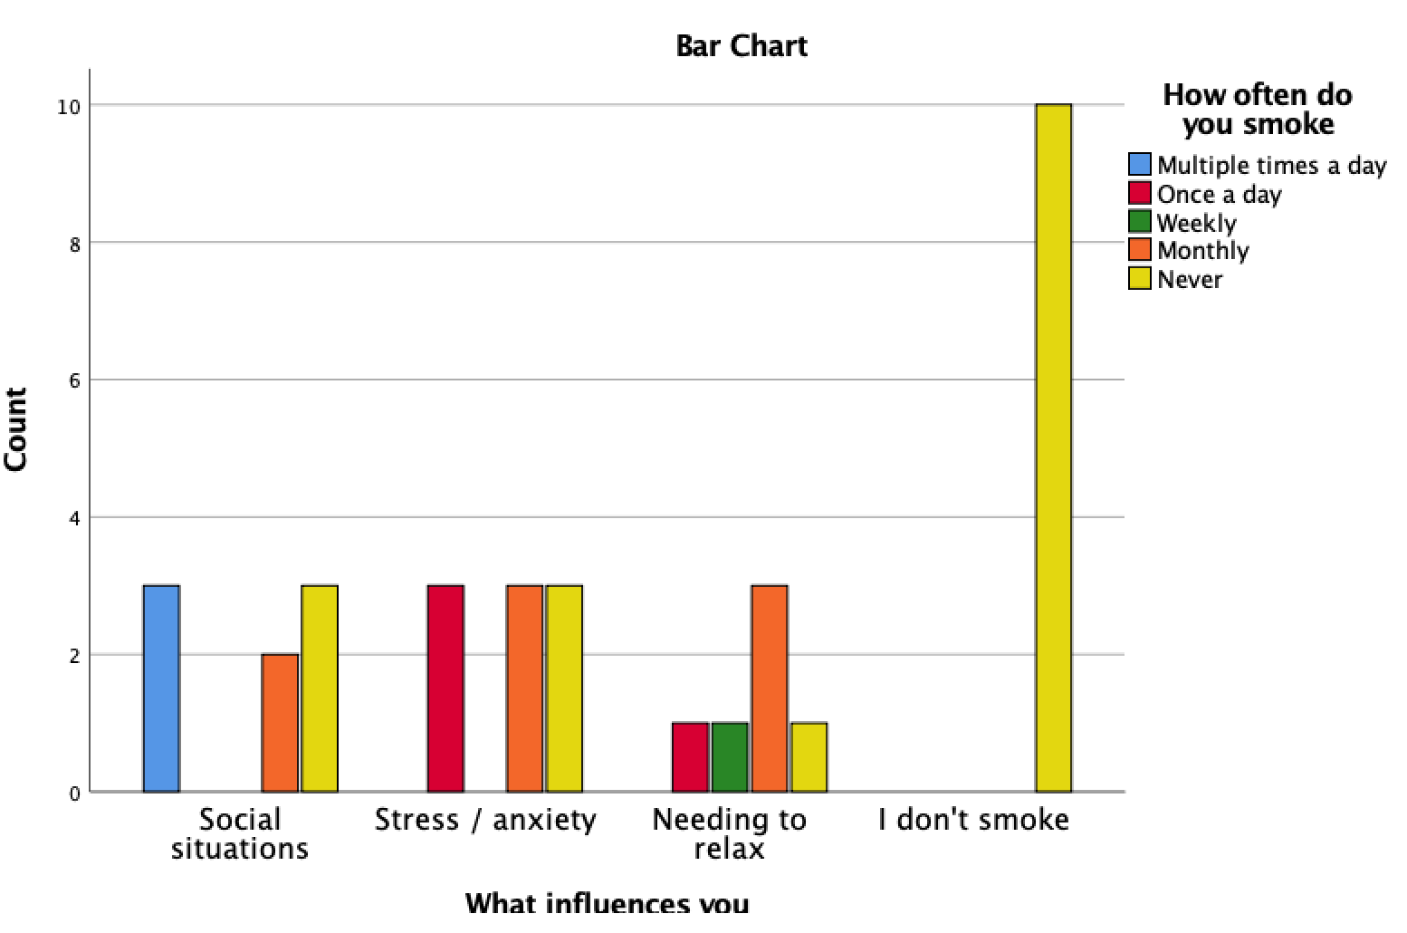

Social situations where the most common answer for people who smoked multiple times a day, followed by the need to de-stress and cope with anxiety.  Due to China’s population growth – 1.37 billion people at last count – the actual number of smokers has continued to increase. Rising prosperity means cigarettes have become more affordable, while low taxes keep the cost of some brands at less than US$1 a pack. During our survey, what we found was that, most of the youth population that was smoking mainly where influenced by their peers, and because of what they say on social media and television.

**Table 4:** Frequency of smoking x hobbies

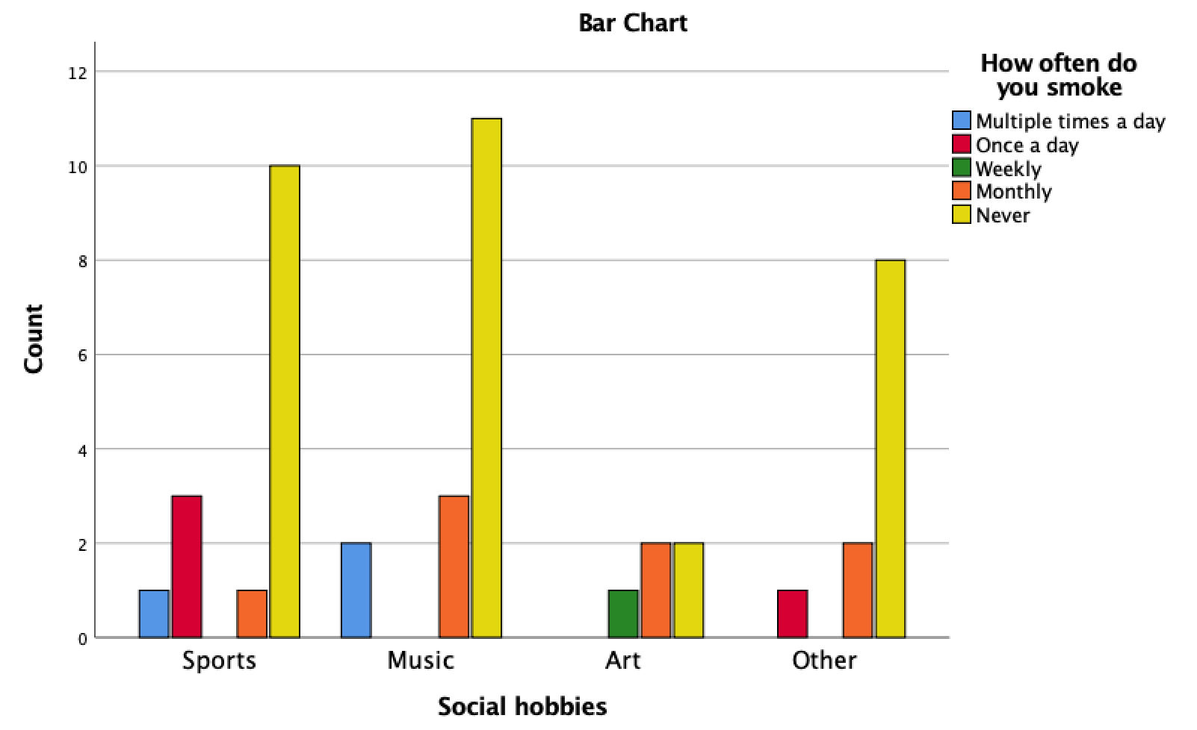

Sports is the leading hobby for preventing smoking. Although music has the highest result for non-smokers, it also has the highest result for smoking multiple times as day.  Friends and celebrities / athletes are the biggest influencers for smoking’s. To further expand, most of the Chinese influence is due to the media, what the youth see of TV as “cool” and what their friends do that is popular and “cool” smoking is deemed as cool in the media and among friends.

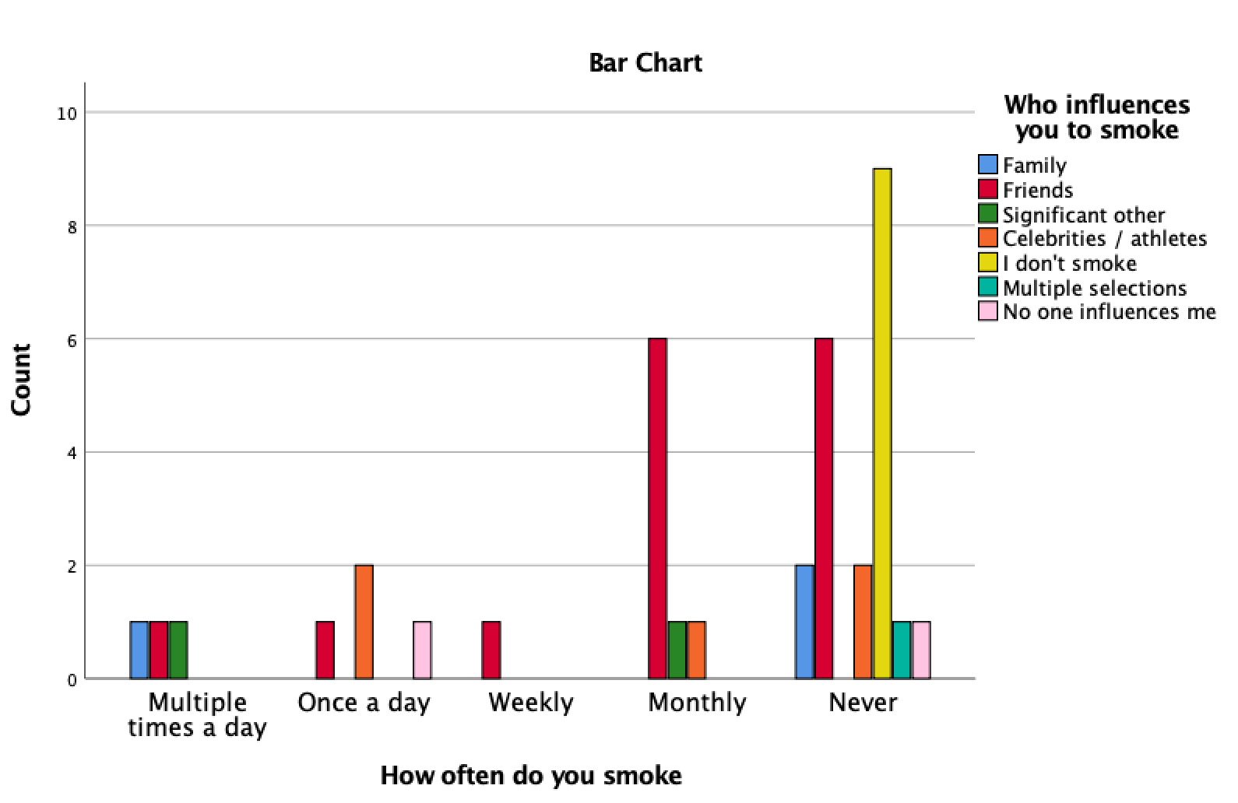

**Table 5:** Frequency of smoking x influences

Through the insight gained from this survey as well as the research completed on this topic, this **c**ampaign will comprise of three key factors: young individuals, taxes and sports. Previous non-smokers campaigns have proven that sports can have a great influence in whether a young individual starts smoking or not.

# **Our Campaign**

We want children and adolescents to get more involved into the sport’s world, while they need an incentive. Therefore, the strategy will consist in a 360 campaign. The first step will be to create a scholarship’s program for kids and adolescents. This will consist in several scholarships which will pay for the full or partial tuition of Chinese athletes in prestigious and foreign universities, with the condition of been clean and not using drugs, like the tobacco. The objective is to motivate young individuals to focus more on sports and discourage smoking behaviors. In order to accomplish this, we need the Chinese Government to be able to increase the cigarette taxes. Our job is to bring awareness to the campaign where this extra money will be directly used to create scholarships for young athletes who do not smoke. Studies have proven that the most effective way to decrease the use of tobacco is by increasing taxes.  Western Pacific Region (WHO**)** states that ‘tobacco tax increases are widely regarded as one of the most effective measures for reducing tobacco consumption’ and thus creates a ‘discouraging prospective for new smokers’*.*Also, from the South China Post, they found data that suggested that the Chinese have fallen slowly over the past 25 years, by about one per cent annually among men and 2.6 per cent among women, according to a separate study published in April in the medical journal *The Lancet* (South China Post).

Nevertheless, with a scholarship fund we would be able to keep the good reputation of China’s Government after the taxes policy is applied.  Wakefield et al (2010) ‘In the role of the media in promoting and reducing tobacco’ (2008) The *National cancer institute of tobacco* states that “Smoking prevention in young people seems to have more likely when mass media efforts were combined with programs in schools, the community or both”. Wakefield et al (2010) ‘In the role of the media in promoting and reducing tobacco’ (2008) The *National cancer institute of tobacco* states that “Smoking prevention in young people seems to have more likely when mass media efforts were combined with programs in schools, the community or both”.

The communication campaign will develop the following two actions:

1. A specific message transmitted through the teachers to the students, explaining the benefits they can receive from non-smoking.
2. We will develop a communication campaign through the social media platforms used in China – Wechat, Weibo, QQ zone and Zhihu— to inform the new generation not only about the dangers of smoking, but, also, they get to play their favorite sport and earn a scholarship for university studies.  The scholarship will focus in the most popular Chinese sports: running, badminton, table tennis, basketball and soccer.

To distribute this effectively we thought of applying the use of ‘native advertising’ within our editorial piece for our scholarship program, that will not only highlight the educational benefits but implement a subconscious awareness of viewing smoking as a direct negative impact towards their future goals. This form of advertising will showcase our communication program as one that enables not only the older demographic of our target audiences (parents) to be attentive when it comes to our antismoking provocations, but it will persuade and captivates the youth's minds and hearts through their passion for their future aspirations. Knoll (2015) states that this form of advertising is often in the form of “converged media” and this is “designed to blur the boundaries between a journalisms organization editorial and an advertising operation” piece, however it is seen as a ‘win-win’ situation for both the consumers and producers involved.

Harms et al (2017, pg. 81) speaks of two stages of having effective integrated advertising these two include brand prominence—our communication governmental program—and message appeal—anti-smoking persuasion. Brand prominence is best achieved through the sense of ‘visibility,’ and Harm states that there needs to be a balance to ensure that the users do not see too much of this as it creates a rigorous or traditional advertising stance. Therefore, we shall ensure to showcase that it is a governmental scheme but will allow this to foreshadow our whole editorial piece. The use of an experience campaign also helps build our visibility. Message appeal can be informative or emotive, and Zaidner (2008) argues for native advertising by explaining that “most digital messages contain emotional appeals, which invoke greater consumer engagement,” and this is exactly what we overall seek to achieve through our scholarship sports program and communication campaign.

To complete an effective 360 campaign, we thought of also ensuring that our communication program has some of the key element to create a successful campaign to our audience. This will be achieved through the act of ‘entertain me,’ ‘inform me’ and ‘reward me.’ This shall be done by including an aspect of experience marketing, where we will not only captivate our young audience to our reforming act and scholarship program but to aalso use this in a rewarding element by creating a ‘viral effect’ and shock tactic.

This form of communication will be showcased as not only a semiotic, but an experience form of marketing campaign to the youth and the public. Therefore, targeting the youth and their families who are key influencers for behavior will allow the campaign to not just act as a form of communication, but serve as a way to change people’s cultural norms through factual demonstrations. This will be done by showcasing this public campaign event in 3 key populous tier 1 cities in China, and 2 economically underdeveloped / poor cities. Looking at not only modern and urban cities will help us ensure that our campaign is not only effective in its number of reach, but effective by focusing in regions with high levels of smoking. Chen et al (2018) has shown that cities that are economically underdeveloped have the most smokers, which was found through an analysis of data from the 2014 China labor force survey. The survey concentrated on the lowest GDP per capita cities to prove the correlations between higher smoking habits linked to poorer cities. Therefore, the concentrated cities that we will focus on will include the following:

1. -Shanghai (34 million)
2. -Guangzhou (25 million)
3. -Beijing (24.9 million)
4. -Guizhou (34.7 million)
5. -Yunnan (45.9 million)

When looking at these cities we also researched what were the main differences between the societies within them. We noted that Beijing, Shanghai and Guangzhou noticeably have a lot of historical links to tradition but are still seen as very contemporary and urban cities. Therefore, we will aim to tailor our appeal by having more popular influencers in that region. Cities such as Guizhou and Yunnan, which are some of the poorest within the country, will have local influencers who know the locality of the people. This will aid our campaign by being more relatable and thus influential to our target audience within those areas.

The campaign itself will include 5 key social media influencers or local celebrities within the different cities, where each city will have a specific influencer/s that is best known within the youth demographic of that region. We shall contact key influencers who are interested in this campaign to participate in tournaments and other physical activities to raise awareness of the dangers of smoking and promote the scholarship for sports. The campaign will also use social media platforms such as WeChat, Weibo, QQ Zone and Zhihu in order to raise awareness for our scholarship for student athletes who do not smoke. As only athletes who do not smoke are eligible for this scholarship, it will encourage our target audience to not pick up this habit and to encourage those who do smoke to stop. As our survey indicated the majority who smoke do so because of stress and anxiety (table 3), encouraging our audience to participate in sports will help them manage their stress and anxiety, and therefore eliminate the need to smoke. Furthermore, it creates networks for our audience with others who do not smoke will also eliminate the peer-pressure of smoking.

A visual element of our campaign will include a large glass tower, which will be presented in an abstract element by being filled with cigarettes that is equal to the daily amount people in China smoke. This will visual campaign will also feature bags that audience members can lift to demonstrate how much of secondary smoke they are exposed to daily—regardless of if they smoke or not. These shock tactics will be designed to educate our audience the many ways smoking affects day-to-day life, let alone all the negative health affects it causes. These events will be livestreamed, as it allows for a larger presence in person and online, and through the use of social media live content, it will create a ‘viral’ effect that is shared among friends, creating a wider reach. A key component to this campaign will be the use of a key quirky hashtag that will be used by the local influencers—#blowit. Through the #blowit tag, it will encourage the audience to ‘blow off’ the idea of partaking in smoking completely. This tag will allow for audience members to show how they are deciding to smoke and create a digital platform for discussion revolving the many negative affects smoking has and allow for sharing alternative habits such as sports.

By doing so it will also meet another objective of ours besides motivating young people to become healthier, it will do this by reaching an emotive form of communication, “Many campaigns aim to directly affect individual recipients by invoking cognitive or emotional responses. Such programs are intended to affect decision-making processes” as stated within Wakefield et al (2010). The use of celebrity culture integrating with our campaign here we have noted will also help us grasp our target audience by ensuring the powerful effect of star idolization and identification link towards encouraging them ‘rewarding them’ by changing their attitudes to smoking. It will also aid us to use this campaign as a gateway into the youth focusing further on the sports scholarship campaign. Bennett (2003, pg. 147) explains through Castells 1997 that ‘the quality of networks contracts sharply to the modernist tendency to forge social and political order through mutual identification with leaders' ideologies and memberships in conventional social and political groups”.

# **Conclusion**

Smoking is a harmful habit that harms not only those who smoke, but everyone else around them tough second hand smoking. Unfortunately, there are too many adolescents in China who still chose to smoke. As they do not understand the terrible impacts it can have on their health, and others because they feel it necessary in order to make new friends or use it as a way to coup stress and anxiety. By creating a digital campaign that centers around public figures and sports, it will provide the instruments these adolescents need to be well-informed in the effects smoking has; the many hobbies they can pick up, such as sports, instead. By increasing the taxation of cigarettes, it will not only discourage adolescents to not smoke, but the scholarships funded by the taxes earned from sales of cigarettes will provide an incentive for our audience to choose participating in sports over smoking. While this is not a fast solution to preventing youth smoking, it will at least start the process of changing societal views that support smoking, and instead redirect this interest back into sports.

**Bibliography**

1. CECC.GOV.  Freedom of expression in China: a privilege, not a right, *Congressional- executive commission on China,*[online], Available at: https://www.cecc.gov/freedom-of-expression-in-china-a-privilege-not-a-right, Accessed on [11/12/2018]
2. Chen, Y et al. (2018) *Effect of characteristics and life in cities in China on residents’ smoking behaviors.* Sage Journals.
3. Gary, King, Pan, Jennifer & Roberts, Margaret E. (2013) How censorship in China allows government criticism but silences collective expression, *American political science review*, Volume 107, Issue 2, pgs. 326-343
4. Harms, Bianca, Tammo H.A, Bijmolt & Hoekstra, C Janny. (2017). Digital Native advertising: practitioner perspectives and a research agenda, J*ournal of interative advertising,* Volume 1, Issue 2, pgs. 80-91, [online], Available at: https://doi.org/10.1080/15252019.2017.1357513, Accessed on [19/12/2018]
5. Knoll, S. (2015). Native advertising and sponsored content: research on audience, ethics, effectiveness – Journalists resource, *Journalists resource*, [online], Available at: https://journalistsresource.org/studies/society/news-media/native-advertising-sponsored-content-audience-ethics-effectiveness/, Accessed on [19/12/2018]
6. Pan, J. & Han, W. (2017). Exploring the intergenerational persistence of health behavior: an empirical study of smoking from China, Available at:<https://bmcpublichealth.biomedcentral.com/track/pdf/10.1186/s12889-017-4480-8> , Accessed on [01/12/2018]
7. Tsung O. Cheng. (1999). Teenage Smoking in China, Available at:<https://ac.els-cdn.com/S0140197199902567/1-s2.0-S0140197199902567-main.pdf?_tid=d1508aa8-01fa-4168-8ccf-2ddaea1bf2d5&acdnat=1543945285_5002f91439a5e270d2dbe8ea4b9d5a02>, Accessed on[ 16/11/2018]
8. W. Bennett. (2003). Communicating global activism information communication and society, Volume 6, Issue 2, pgs. 143-168, [online], Available at: <https://doi.org/10.1080/1369118032000093860a> , Accessed on [10/12/2018]
9. Wakefield, M. A, Liken, B., & Hornik, R.C. (2010). Use of mass media campaigns to change health behavior, Volume 376, pages 1261-71, Lancet: London
10. WHO Western Pacific Region, *Tobacco in China,* [online], Available at: <http://www.wpro.who.int/china/mediacentre/factsheets/tobacco/en/>, Accessed on [17/12/2018]
11. Xu, B. and Albert, E. (2017). Media Censorship in China, *Council on Foreign Relations*, [online], Available at: https://www.cfr.org/backgrounder/media-censorship-china, Accessed on [17/12/2018].
12. Xu, B. and Albert, E. (2017). *Media Censorship in China*. [online] Council on Foreign Relations. Available at: https://www.cfr.org/backgrounder/media-censorship-china, Accessed on [17/12/2018]